CMR INSTITUTE OF TECHNOLOGY

Affiliated to Visvesvaraya Technological University(VTU) Sri Nivasa Reddy Layout, AECS Layout,
Marathahalli,Bengaluru, Karnataka 560037



Department of Information Science and Engineering
LAB MANUAL
MACHINE LEARNING LAB (BCSL606)
Academic Year : 2025-26

Semester-VI Scheme-2022

Page 1 of 40

Course Objectives (Defined by the university):

At the end of the course, the student will be able to :
1. Describe the machine learning techniques, their types, and the data analysis framework.
2. Apply mathematical concepts for feature engineering and perform dimensionality reduction to enhance model performance.
3. Develop similarity-based learning models and regression models for solving classification and prediction tasks.
4. Build probabilistic learning models and design neural network models using perceptrons and multilayer architectures
5. Utilize clustering algorithms to identify patterns in data and implement reinforcement learning techniques.

List of Problems/Experiments

 | Experiments
 | List of problems for which students should develop the program and execute it in the laboratory
1 | Develop a program to create histograms for all numerical features and analyze the distribution of each feature. Generate box plots for all numerical features and identify any outliers. Use California Housing dataset.
2 | Develop a program to Compute the correlation matrix to understand the relationships between pairs offeatures. Visualize the correlation matrix using a heatmap to know which variables have strongpositive/negative correlations. Create a pair plot to visualize pairwise relationships between features. Use California Housing dataset.
3 | Develop a program to implement Principal Component Analysis (PCA) for reducing the dimensionality of the Iris dataset from 4 features to 2.
4 | For a given set of training data examples stored in a .CSV file, implement and demonstrate the Find-S algorithm to output a description of the set of all hypotheses consistent with the training examples.
5 | Develop a program to implement k-Nearest Neighbour algorithm to classify the randomly generated 100  values of x in the range of [0,1]. Perform the following based on dataset generated.  - Label the first 50 points {x1,......,x50} as follows: if (xi ≤ 0.5), then xi ∊  Class1, else xi ∊ Class1  - Classify the remaining points, x51, ,x100 using KNN. Perform this for k=1,2,3,4,5,20,30
6 | Implement the non-parametric Locally Weighted Regression algorithm in order to fit data points. Select appropriate data set for your experiment and draw graphs
7 | Develop a program to demonstrate the working of Linear Regression and Polynomial Regression. Use Boston Housing Dataset for Linear Regression and Auto MPG Dataset (for vehicle fuel efficiency prediction) for Polynomial Regression.
8 | Develop a program to demonstrate the working of the decision tree algorithm. Use Breast Cancer Data set for building the decision tree and apply this knowledge to classify a new sample.

9 | Develop a program to implement the Naive Bayesian classifier considering Olivetti Face Data set for training. Compute the accuracy of the classifier, considering a few test data sets.
10 | Develop a program to implement k-means clustering using Wisconsin Breast Cancer data set and visualize the clustering result.

Experiment 1: Develop a program to create histograms for all numerical features and analyze the distribution of each feature. Generate box plots for all numerical features and identify any outliers. Use California Housing dataset.
Code:
import pandas as pd import numpy as np
import matplotlib.pyplot as plt import seaborn as sns
from sklearn.datasets import fetch_california_housing # Load the California Housing dataset
data = fetch_california_housing(as_frame=True) df = data.frame
# Display the first few rows of the dataset print("Dataset Sample:")
print(df.head())

# Plot histograms for all numerical features def plot_histograms(df):
df.hist(figsize=(12, 10), bins=30, color='skyblue', edgecolor='black') plt.suptitle('Histograms of Numerical Features', fontsize=16) plt.tight_layout(rect=[0, 0, 1, 0.97])
plt.show()

# Plot box plots for all numerical features def plot_boxplots(df):
plt.figure(figsize=(14, 10))

for i, column in enumerate(df.columns, 1): plt.subplot(3, 3, i)

sns.boxplot(y=df[column], color='skyblue') plt.title(f"Box Plot of {column}", fontsize=12) plt.tight_layout()
plt.show()
# Analyze distribution and detect outliers def analyze_features(df):
print("\nFeature Analysis:") for column in df.columns:
print(f"\nFeature: {column}")
print(f"Mean:
{df[column].mean():.2f},
Median:
{df[column].median():.2f}, Std Dev: {df[column].std():.2f}") q1 = df[column].quantile(0.25)
q3 = df[column].quantile(0.75) iqr = q3 - q1
lower_bound = q1 - 1.5 * iqr

upper_bound = q3 + 1.5 * iqr
outliers
upper_bound)]
=
df[(df[column] < lower_bound) | (df[column] >
print(f"Number of Outliers: {len(outliers)}") # Plot histograms and boxplots, and analyze features plot_histograms(df)
plot_boxplots(df)

analyze_features(df)

Output:

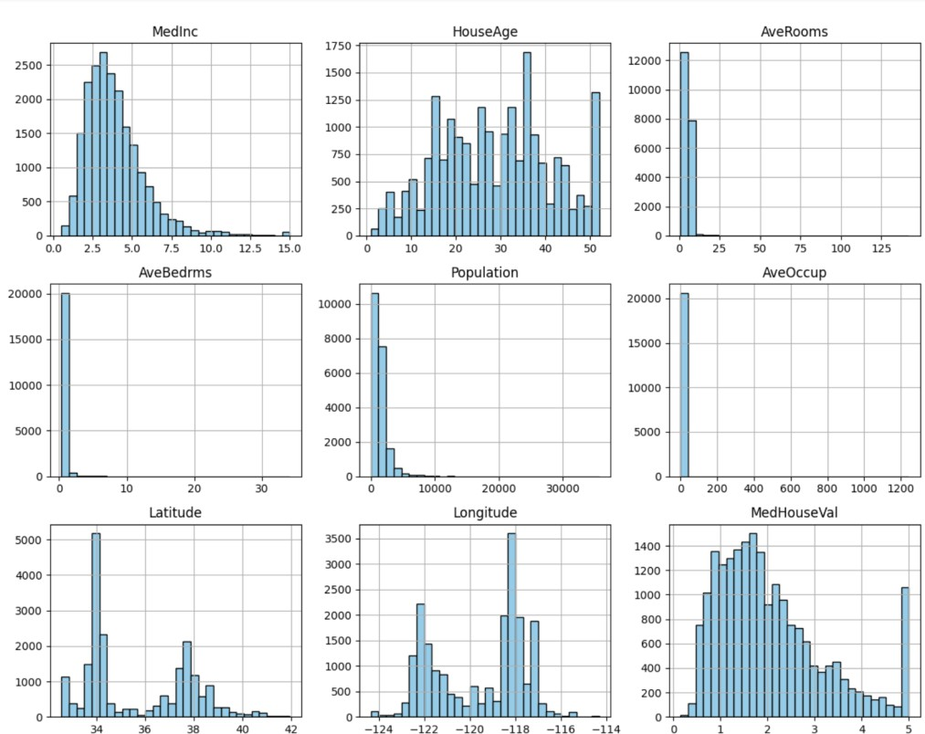

Experiment 2: Develop a program to Compute the correlation matrix to understand the relationships between pairs offeatures. Visualize the correlation matrix using a heatmap to know which variables have strongpositive/negative correlations. Create a pair plot to visualize pairwise relationships between features. Use California Housing dataset.
Code:
import pandas as pd import seaborn as sns
import matplotlib.pyplot as plt

from sklearn.datasets import fetch_california_housing # Load the California Housing dataset
data = fetch_california_housing(as_frame=True) df = data.frame
# Display the first few rows of the dataset print("Dataset Sample:")
print(df.head())

# Compute the correlation matrix correlation_matrix = df.corr() # Print the correlation matrix print("\nCorrelation Matrix:") print(correlation_matrix)
# Visualize the correlation matrix using a heatmap def plot_heatmap(corr_matrix):
plt.figure(figsize=(10, 8))
sns.heatmap(corr_matrix,
annot=True,
fmt=".2f",
cmap="coolwarm",
cbar=True, square=True, linewidths=0.5) plt.title("Correlation Matrix Heatmap", fontsize=16)
plt.show()

# Create a pair plot to visualize pairwise relationships def plot_pairplot(df):
sns.pairplot(df, diag_kind="kde", corner=True, plot_kws={'alpha': 0.5}, diag_kws={'fill': True})
plt.suptitle("Pair Plot of Numerical Features", y=1.02, fontsize=16) plt.show()
# Plot the heatmap and pair plot
plot_heatmap(correlation_matrix) plot_pairplot(df)

Output
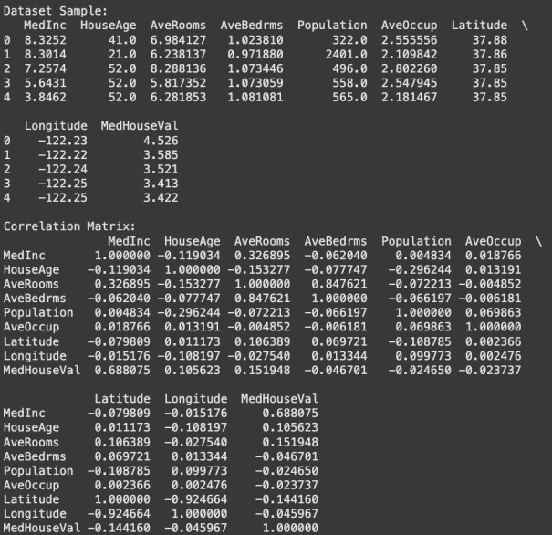

Experiment 3: Develop a program to implement Principal Component Analysis (PCA) for reducing the dimensionality of the Iris dataset from 4 features to 2.
Code:
import pandas as pd

import matplotlib.pyplot as plt

from sklearn.datasets import load_iris from sklearn.decomposition import PCA
from sklearn.preprocessing import StandardScaler # Load the Iris dataset
iris = load_iris()

X = iris.data

y = iris.target

target_names = iris.target_names

# Standardize the features (mean = 0, variance = 1) scaler = StandardScaler()
X_standardized = scaler.fit_transform(X)

# Apply PCA to reduce dimensions from 4 to 2 pca = PCA(n_components=2)
X_pca = pca.fit_transform(X_standardized) # Create a DataFrame for the PCA results
pca_df = pd.DataFrame(data=X_pca, columns=['Principal Component 1', 'Principal Component 2'])
pca_df['Target'] = y # Plot the PCA results
plt.figure(figsize=(8, 6))

for target, color, label in zip(range(len(target_names)), ['r', 'g', 'b'], target_names):
plt.scatter(

pca_df.loc[pca_df['Target'] == target, 'Principal Component 1'], pca_df.loc[pca_df['Target'] == target, 'Principal Component 2'], color=color,
alpha=0.6, label=label
)

plt.title('PCA of Iris Dataset (2 Components)', fontsize=16) plt.xlabel('Principal Component 1', fontsize=12) plt.ylabel('Principal Component 2', fontsize=12) plt.legend(title='Target', loc='best')
plt.grid(alpha=0.3)

plt.show()

Output:

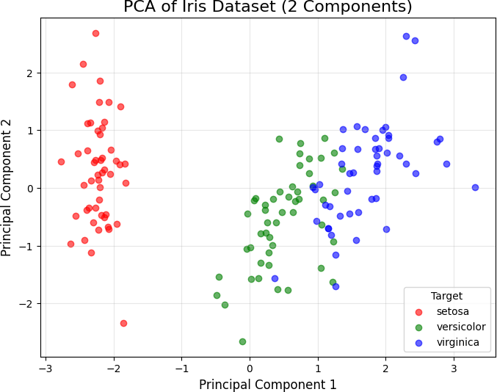

Experiment 4: For a given set of training data examples stored in a .CSV file, implement and demonstrate the Find-S algorithm to output a description of the set of all hypotheses consistent with the training examples.
Code:
import pandas as pd

# Define the data as a dictionary data = {
"Weather": ["Sunny", "Sunny", "Rainy", "Sunny"],

"Temperature": ["Warm", "Warm", "Cold", "Warm"],

"Humidity": ["Normal", "High", "High", "High"],

"Wind": ["Strong", "Strong", "Strong", "Weak"],

"PlayTennis": ["Yes", "Yes", "No", "Yes"]

}

# Convert the data into a DataFrame df = pd.DataFrame(data)
# Save the DataFrame to a CSV file file_path = "training_data.csv" df.to_csv(file_path, index=False)
print(f"CSV file 'training_data.csv' has been created successfully!") def find_s_algorithm(data):
# Extract features and labels
features = data.iloc[:, :-1].values
(attributes)
# All columns except the
last
labels = data.iloc[:, -1].values
# The last column (class/label)
# Initialize the hypothesis as the first positive example

hypothesis = None

for i, label in enumerate(labels):

if label == "Yes": # Look for a positive example

hypothesis = features[i].copy()

break

# If no positive examples, return empty hypothesis

if hypothesis is None:

return "No positive examples found."

# Generalize hypothesis for each positive example

for i, label in enumerate(labels):

if label == "Yes": # Process only positive examples

for j in range(len(hypothesis)):

if hypothesis[j] != features[i][j]: # If attributes differ,
make it '?'

hypothesis[j] = '?'

return hypothesis

# Load training data from a CSV file

file_path = "training_data.csv" # Replace with your CSV file path

data = pd.read_csv(file_path)

# Display the training data

print("Training Data:")

print(data)

# Run the Find-S algorithm final_hypothesis = find_s_algorithm(data)

# Output the final hypothesis print("\nFinal Hypothesis:")
print(final_hypothesis)

Output
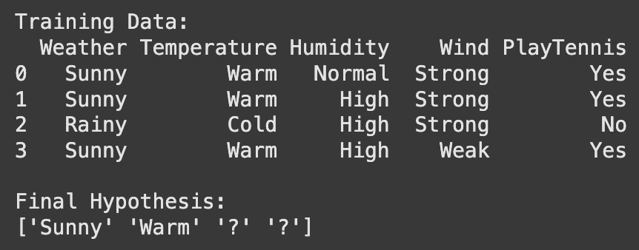

Experiment 5: Develop a program to implement k-Nearest Neighbour algorithm to classify the randomly generated 100 values of x in the range of [0,1]. Perform the following based on dataset generated.
- Label the first 50 points {x1,......,x50} as follows: if (xi ≤ 0.5), then xi
∊ Class1, else xi ∊ Class1
- Classify the remaining points, x51, ,x100 using KNN. Perform this for k=1,2,3,4,5,20,30
Employee(E_id, E_name, Age, Salary)
Code:
import numpy as np

from sklearn.neighbors import KNeighborsClassifier # Step 1: Generate random dataset np.random.seed(42) # For reproducibility
x = np.random.rand(100) # 100 random values in the range [0, 1] # Step 2: Label the first 50 points
labels = np.where(x[:50] <= 0.5, 1, 2) # Class1 = 1, Class2 = 2 # Combine the labeled data into a training set
x_train = x[:50].reshape(-1, 1) y_train = labels
# The remaining 50 points to classify x_test = x[50:].reshape(-1, 1)
# Step 3: k-NN classification k_values = [1, 2, 3, 4, 5, 20, 30] print("k-NN Classification Results:") for k in k_values:
knn = KNeighborsClassifier(n_neighbors=k) knn.fit(x_train, y_train) # Train the k-NN model
y_pred = knn.predict(x_test) # Predict classes for the test points # Output the predictions for this k value

print(f"\nk = {k}:")

print(f"Predicted Classes: {y_pred}")

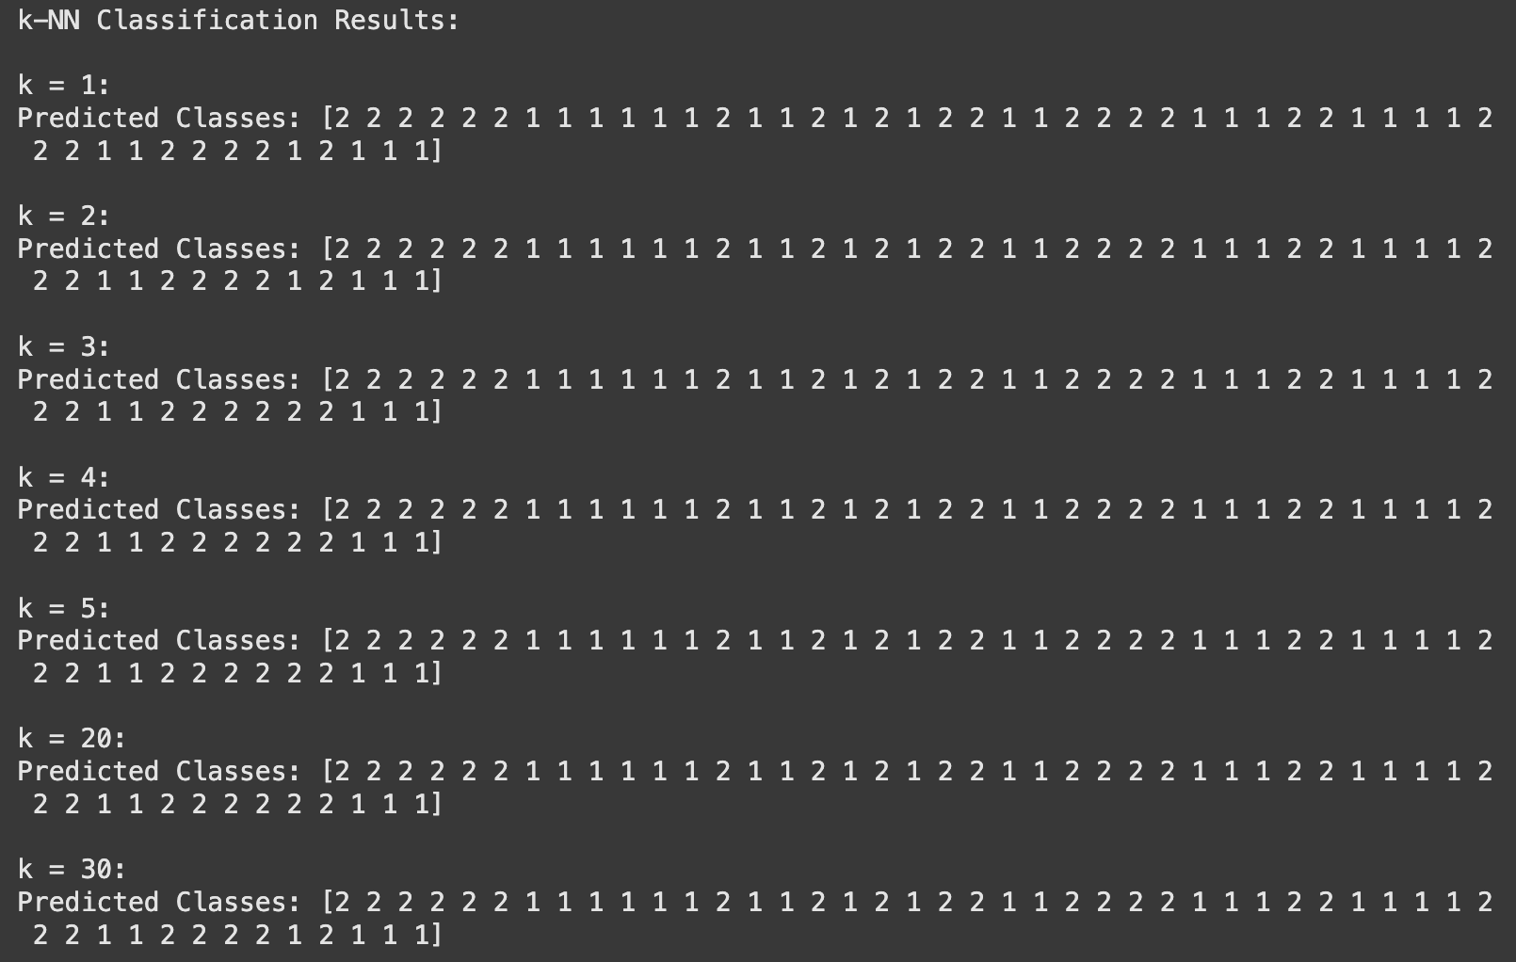
Output

Experiment 6: Implement the non-parametric Locally Weighted Regression algorithm in order to fit data points. Select appropriate data set for your experiment and draw graphs.
import pandas as pd
import numpy as np
import matplotlib.pyplot as plt
tou= 0.5
#The bandwidth parameter τ decides the width of the neighborhood you should look into to fit the local straight line.
#TRAIN SET DATA
X_train = np.array(list(range(3, 33)) ) #Creates array X_train containing integers from 3 to 32
print(X_train)
X_train=X_train[:,np.newaxis] #convert a 1D NumPy array into a 2D column vector
print(X_train)
y_train=np.array([1,2,1,2,1,1,3,4,5,4,5,6,5,6,7,8,9,10,11,11,12,11,11,10,12,11,11,10,9,8])
print(y_train)
#the new axis is used to increase the dimension of the existing array by one more dimension
plt.scatter(X_train,y_train)
X_test = np.array([i/10. for i in range(400)]) #This generates 400 evenly spaced test points between 0.0 and 39.9
print(X_test)
X_test=X_test[:,np.newaxis] #1D array into a 2D column vector, required for matrix operations in LWR
print(X_test)
y_test=[] #Creates an empty list y_test to store the predicted values from LWR.
print(y_test)
X_test.shape
for r in range(len(X_test)):
#This Gaussian weight function assigns a weight to each training point based on its distance from the current test point[r].
wts=np.exp(-np.sum((X_train-X_test[r])**2,axis=1)/(2*tou)**2)
W=np.diag(wts)
#constant value
factor1 = np.linalg.inv(X_train.T.dot(W).dot(X_train)) # find inverse of (X.T*W*X)
parameters= factor1.dot(X_train.T).dot(W).dot(y_train) # final values of beta
prediction=X_test[r].dot(parameters)
y_test.append(prediction)
y_test = np.array(y_test)
plt.scatter(X_train, y_train)
plt.scatter(X_test, y_test, color='red')
plt.xlabel('X')
plt.ylabel('Y')
plt.show()

Output

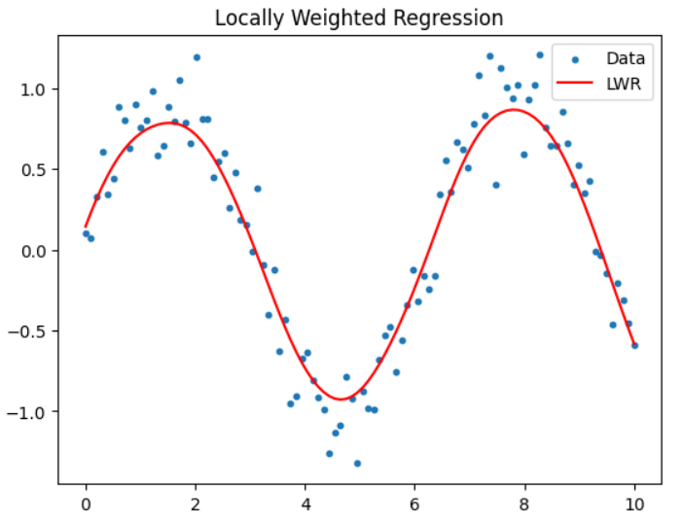

Experiment 7:. Develop a program to demonstrate the working of Linear Regression and Polynomial Regression. Use Boston Housing Dataset for Linear Regression and Auto MPG Dataset (for vehicle fuel efficiency prediction) for Polynomial Regression.
Code:
import numpy as np
import matplotlib.pyplot as plt
from sklearn.datasets import fetch_california_housing, fetch_openml from sklearn.linear_model import LinearRegression
from sklearn.preprocessing import PolynomialFeatures from sklearn.model_selection import train_test_split from sklearn.metrics import mean_squared_error, r2_score

# --- Linear Regression with California Housing Dataset --- def linear_regression_california():
# Load California Housing Dataset cali_housing = fetch_california_housing()
X = cali_housing.data
y = cali_housing.target

# Split into train and test sets
X_train, X_test, y_train, y_test = train_test_split(X, y, test_size=0.2, random_state=42)

# Train a linear regression model lin_reg = LinearRegression() lin_reg.fit(X_train, y_train)

# Predictions
y_pred = lin_reg.predict(X_test)

# Performance metrics
mse = mean_squared_error(y_test, y_pred) r2 = r2_score(y_test, y_pred)

# Plotting plt.figure(figsize=(10, 6))
plt.scatter(y_test, y_pred, alpha=0.6)

plt.plot([min(y_test), max(y_test)], [min(y_test), max(y_test)], color="red", linewidth=2)
plt.xlabel("True Values (California Housing)") plt.ylabel("Predicted Values")
plt.title("Linear Regression on California Housing Dataset") plt.grid(True)
plt.show()
print(f"Linear Regression Results:") print(f"Mean Squared Error: {mse:.2f}") print(f"R^2 Score: {r2:.2f}")

# --- Polynomial Regression with Auto MPG Dataset --- def polynomial_regression_auto_mpg():
# Load Auto MPG Dataset
auto_mpg = fetch_openml(name="autoMpg", version=1, as_frame=True) data = auto_mpg.data
target = auto_mpg.target

# Remove rows with missing 'horsepower' values from both data and target
data = data.dropna(subset=["horsepower"])
target = target.loc[data.index] # Ensure target is aligned with filtered data
# Select feature (Horsepower) and target (MPG)
X_hp = data[["horsepower"]].astype(float) # Horsepower as feature y_mpg = target.astype(float) # Miles per gallon as target

# Train-test split
X_train, X_test, y_train, y_test = train_test_split(X_hp, y_mpg, test_size=0.2, random_state=42)

# Polynomial regression (degree=3) poly_features = PolynomialFeatures(degree=3)
X_train_poly = poly_features.fit_transform(X_train) X_test_poly = poly_features.transform(X_test)

# Train a linear regression model on transformed polynomial features lr_poly = LinearRegression()
lr_poly.fit(X_train_poly, y_train)

# Predictions
y_pred_poly = lr_poly.predict(X_test_poly) # Performance metrics
mse_poly = mean_squared_error(y_test, y_pred_poly) r2_poly = r2_score(y_test, y_pred_poly)
# Sort for plotting
X_test_sorted, y_test_sorted = zip(*sorted(zip(X_test.values.flatten(), y_test)))
y_pred_sorted = lr_poly.predict(poly_features.transform(np.array(X_test_sorted).reshape(- 1, 1)))
# Plot plt.figure(figsize=(10, 6))
plt.scatter(X_test, y_test, color="blue", label="True values", alpha=0.6)
plt.plot(X_test_sorted, y_pred_sorted, color="red", label="Polynomial fit (degree=3)", linewidth=2)
plt.xlabel("Horsepower") plt.ylabel("Miles Per Gallon (MPG)")
plt.title("Polynomial Regression on Auto MPG Dataset") plt.legend()
plt.grid(True) plt.show()
print(f"Polynomial Regression Results (Degree=3):") print(f"Mean Squared Error: {mse_poly:.2f}") print(f"R^2 Score: {r2_poly:.2f}")
# Run both demonstrations def run_models():
linear_regression_california() polynomial_regression_auto_mpg()
# Execute the functions run_models()

Read Operation:

Output
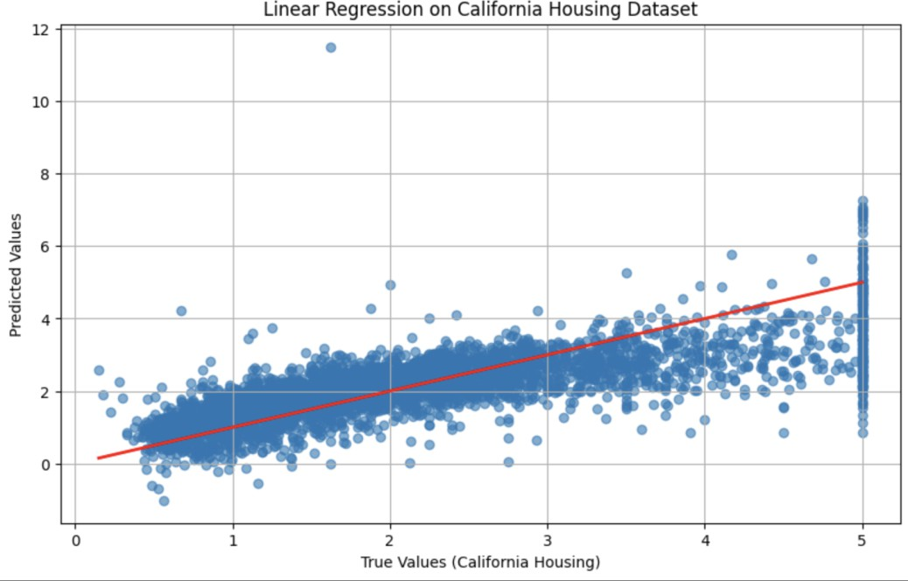
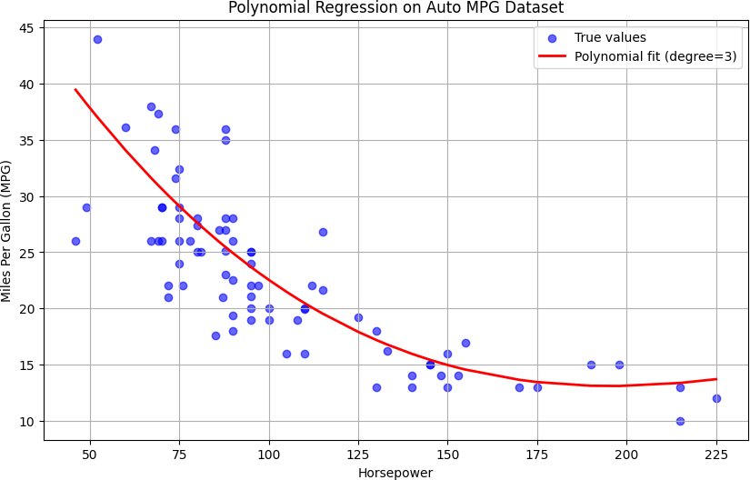



Experiment 8:.
Develop a program to demonstrate the working of the decision tree algorithm. Use Breast Cancer Data set for building the decision tree and apply this knowledge to classify a new sample.
Code:
import numpy as np import pandas as pd
import matplotlib.pyplot as plt
from sklearn.datasets import load_breast_cancer
from sklearn.model_selection import train_test_split
from sklearn.tree import DecisionTreeClassifier, plot_tree
from sklearn.metrics import accuracy_score, classification_report

# Load the Breast Cancer dataset def load_and_preprocess_data():
cancer_data = load_breast_cancer()
X = cancer_data.data y = cancer_data.target
feature_names = cancer_data.feature_names target_names = cancer_data.target_names return X, y, feature_names, target_names

# Train a Decision Tree classifier
def train_decision_tree(X_train, y_train):
clf = DecisionTreeClassifier(random_state=42) clf.fit(X_train, y_train)
return clf

# Plot the Decision Tree
def plot_decision_tree(clf, feature_names): plt.figure(figsize=(12, 8))
plot_tree(clf, filled=True, feature_names=feature_names, class_names=["Malignant", "Benign"], rounded=True, proportion=True)
plt.title("Decision Tree for Breast Cancer Classification") plt.show()

# Classify a new sample
def classify_new_sample(clf, sample): sample = np.array(sample).reshape(1, -1) prediction = clf.predict(sample)

return prediction

# Main function to demonstrate Decision Tree Algorithm def main():
# Load and preprocess data
X, y, feature_names, target_names = load_and_preprocess_data()

# Split the data into training and testing sets
X_train, X_test, y_train, y_test = train_test_split(X, y, test_size=0.2, random_state=42)

# Train the Decision Tree model
clf = train_decision_tree(X_train, y_train)

# Predict on the test set y_pred = clf.predict(X_test)

# Print performance metrics
print("Accuracy Score:", accuracy_score(y_test, y_pred)) print("\nClassification Report:")
print(classification_report(y_test, y_pred, target_names=target_names))

# Plot the decision tree plot_decision_tree(clf, feature_names)

# Classify a new sample (e.g., random sample from the test set) sample = X_test[0] # You can replace this with any sample prediction = classify_new_sample(clf, sample) print(f"\nClassified sample: {'Benign' if prediction == 1 else
'Malignant'}")

# Run the main function
if name == " main ": main()

Output

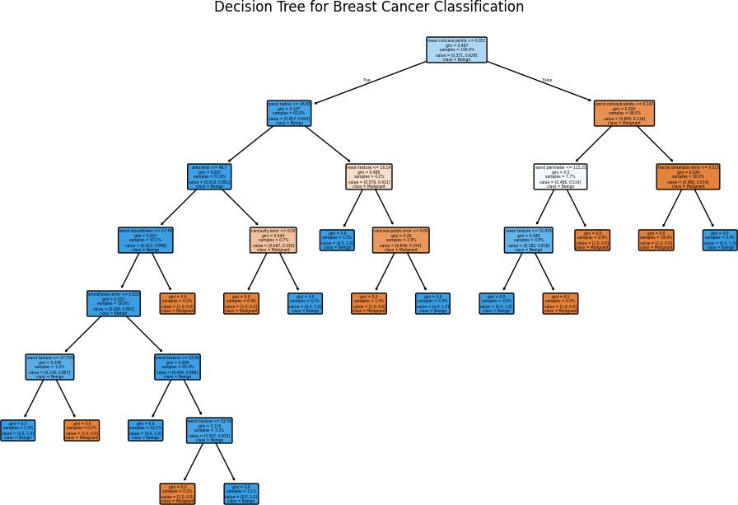

Experiment 9:.
Develop a program to implement the Naive Bayesian classifier considering Olivetti Face Data set for training. Compute the accuracy of the classifier, considering a few test data sets.
Code:

import numpy as np
from sklearn import datasets
from sklearn.model_selection import train_test_split from sklearn.naive_bayes import GaussianNB
from sklearn.metrics import accuracy_score import matplotlib.pyplot as plt

# Function to load and preprocess the Olivetti Face Dataset def load_and_preprocess_data():
faces_data = datasets.fetch_olivetti_faces(shuffle=True, random_state=42)
X = faces_data.data # 4096 features for each face (64x64 pixel images flattened)
y = faces_data.target # Labels for each person (40 classes) return X, y

# Function to split the data into training and testing sets def split_data(X, y, test_size=0.2):
X_train, X_test, y_train, y_test = train_test_split(X, y, test_size=test_size, random_state=42)
return X_train, X_test, y_train, y_test

# Function to train a Naive Bayes classifier def train_naive_bayes(X_train, y_train):
nb_classifier = GaussianNB() nb_classifier.fit(X_train, y_train) return nb_classifier

# Function to predict and calculate accuracy
def predict_and_evaluate(nb_classifier, X_test, y_test): y_pred = nb_classifier.predict(X_test)
accuracy = accuracy_score(y_test, y_pred) return y_pred, accuracy

# Function to visualize a few test samples with predicted labels def visualize_predictions(X_test, y_pred, n_samples=5):
plt.figure(figsize=(10, 5)) for i in range(n_samples):
plt.subplot(1, n_samples, i + 1) plt.imshow(X_test[i].reshape(64, 64), cmap='gray') plt.title(f"Pred: {y_pred[i]}")
plt.axis('off') plt.show()

# Main function to run the program def main():
# Load and preprocess data
X, y = load_and_preprocess_data()

# Split the data into training and testing sets X_train, X_test, y_train, y_test = split_data(X, y)

# Train the Naive Bayes classifier
nb_classifier = train_naive_bayes(X_train, y_train)

# Predict and evaluate the model
y_pred, accuracy = predict_and_evaluate(nb_classifier, X_test, y_test) print(f"Accuracy of the Naive Bayes Classifier on the test set:
{accuracy * 100:.2f}%")

# Visualize predictions on the test set visualize_predictions(X_test, y_pred)

# Run the program
if name == " main ": main()

Output

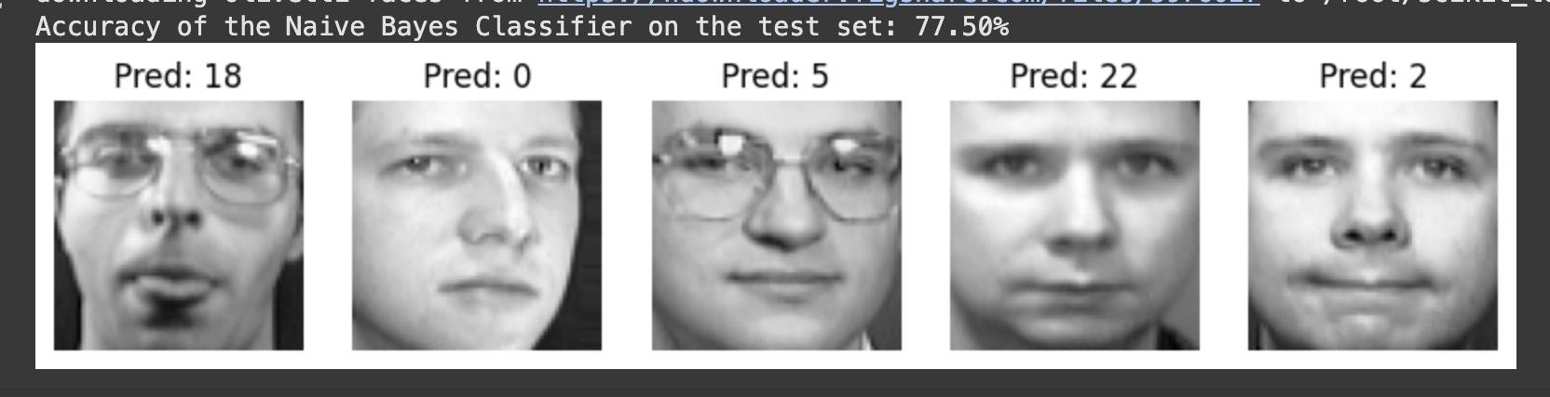

Experiment 10:.
Develop a program to implement k-means clustering using Wisconsin Breast Cancer data set and visualize the clustering result.
Code:
import numpy as np import pandas as pd
from sklearn.datasets import load_breast_cancer from sklearn.cluster import KMeans
from sklearn.preprocessing import StandardScaler import matplotlib.pyplot as plt

# Function to load and preprocess the dataset def load_and_preprocess_data():
# Load the Wisconsin Breast Cancer dataset data = load_breast_cancer()

# Extract features (X) and labels (y)
X = data.data
y = data.target

# Standardize the features scaler = StandardScaler()
X_scaled = scaler.fit_transform(X)

return X_scaled, y

# Function to apply K-Means clustering def apply_kmeans(X, n_clusters=2):
kmeans = KMeans(n_clusters=n_clusters, random_state=42) kmeans.fit(X)

# Return the cluster centers and labels
return kmeans.cluster_centers_, kmeans.labels_

# Function to visualize the clustering result def visualize_clusters(X, labels, centers):
plt.figure(figsize=(8, 6))

# Plot the data points, colored by cluster label plt.scatter(X[:, 0], X[:, 1], c=labels, cmap='viridis', s=50)

# Plot the cluster centers
plt.scatter(centers[:, 0], centers[:, 1], c='red', marker='x', s=200, label='Centroids')

plt.title('K-Means Clustering on Wisconsin Breast Cancer Dataset') plt.xlabel('Feature 1')
plt.ylabel('Feature 2') plt.legend()
plt.show()

# Main function to execute the program def main():
# Load and preprocess the data
X, y = load_and_preprocess_data()

# Apply K-Means clustering (using 2 clusters for simplicity) centers, labels = apply_kmeans(X, n_clusters=2)

# Visualize the clustering results visualize_clusters(X, labels, centers)

# Run the program
if name == " main ": main()

Output

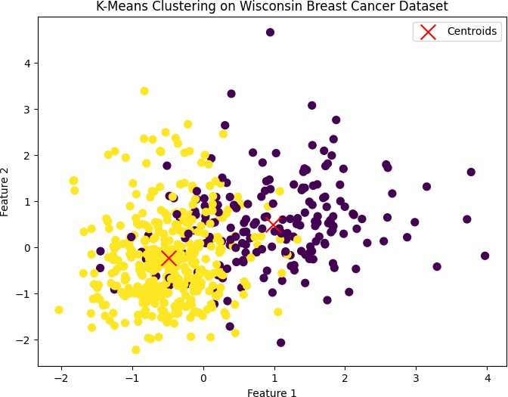

Extra Program 1: Develop a program to implement the Support Vector Machine (SVM) algorithm for binary classification. Use the Pima Indians Diabetes dataset for training and evaluation. Experiment with different kernel functions (linear, RBF, polynomial) and regularization parameters to find the best model.
Code:
import numpy as np import pandas as pd from sklearn import svm
from sklearn.model_selection import train_test_split from sklearn.preprocessing import StandardScaler from sklearn.metrics import accuracy_score
from sklearn.model_selection import GridSearchCV

# Load the Pima Indians Diabetes dataset
url = "https://raw.githubusercontent.com/jbrownlee/Datasets/master/pima- indians-diabetes.data.csv"
columns = ['Pregnancies', 'Glucose', 'BloodPressure', 'SkinThickness', 'Insulin', 'BMI', 'DiabetesPedigreeFunction', 'Age', 'Outcome']
data = pd.read_csv(url, names=columns)

# Split the data into features (X) and target (y)
X = data.iloc[:, :-1].values y = data.iloc[:, -1].values

# Normalize the features scaler = StandardScaler()
X_scaled = scaler.fit_transform(X)

# Split the data into training and testing sets (80% train, 20% test) X_train, X_test, y_train, y_test = train_test_split(X_scaled, y, test_size=0.2, random_state=42)

# Define the SVM models with different kernel functions kernels = ['linear', 'rbf', 'poly']
C_values = [0.1, 1, 10]

# Store results results = []

# Train and evaluate the models for kernel in kernels:
for C in C_values:
print(f"Training SVM with {kernel} kernel and C={C}...")

# Create and train the SVM model model = svm.SVC(kernel=kernel, C=C) model.fit(X_train, y_train)

# Predict on the test set y_pred = model.predict(X_test)

# Calculate accuracy
accuracy = accuracy_score(y_test, y_pred) results.append((kernel, C, accuracy))

# Find the best model
best_model = max(results, key=lambda x: x[2])

# Print results
print("\nModel Evaluation Results:") for result in results:
print(f"Kernel: {result[0]}, C: {result[1]}, Accuracy:
{result[2]:.4f}")

print("\nBest Model:")
print(f"Kernel: {best_model[0]}, C: {best_model[1]}, Accuracy:
{best_model[2]:.4f}")

Output

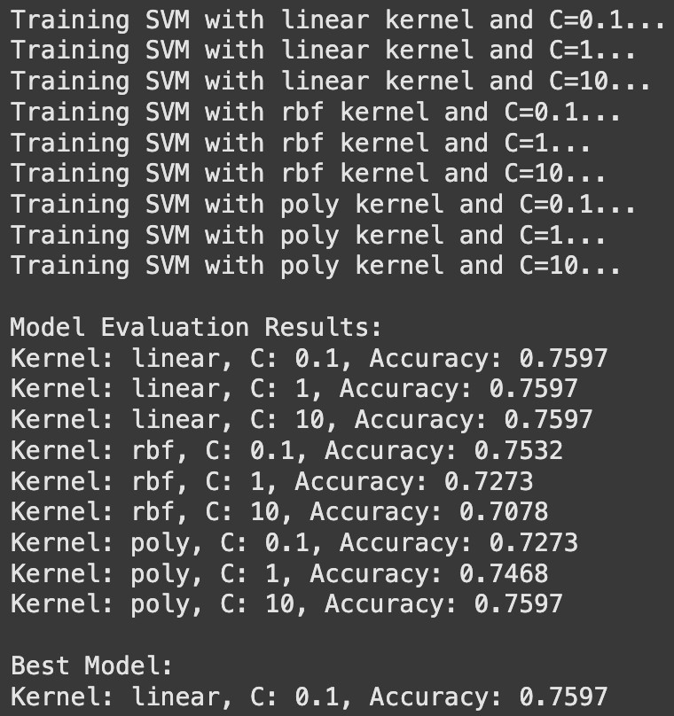

Extra Program 2: Develop a program to implement the AdaBoost algorithm for classification. Use the Pima Indians Diabetes dataset for training and evaluation. Analyze the impact of the number of weak learners on the model's performance and compare the performance of AdaBoost with a single decision tree classifier.
Code:
import numpy as np import pandas as pd
from sklearn.model_selection import train_test_split from sklearn.ensemble import AdaBoostClassifier
from sklearn.tree import DecisionTreeClassifier from sklearn.metrics import classification_report from sklearn.preprocessing import StandardScaler import matplotlib.pyplot as plt

# Load the dataset (Pima Indians Diabetes dataset)
url = "https://raw.githubusercontent.com/jbrownlee/Datasets/master/pima- indians-diabetes.data.csv"
column_names = ['Pregnancies', 'Glucose', 'BloodPressure', 'SkinThickness', 'Insulin', 'BMI', 'DiabetesPedigreeFunction', 'Age', 'Outcome']
data = pd.read_csv(url, names=column_names)

# Split into features and target
X = data.drop('Outcome', axis=1) y = data['Outcome']

# Normalize the data (important for algorithms like AdaBoost) scaler = StandardScaler()
X_scaled = scaler.fit_transform(X)

# Train-test split
X_train, X_test, y_train, y_test = train_test_split(X_scaled, y, test_size=0.2, random_state=42)

# Initialize the base classifier (Decision Tree) base_estimator = DecisionTreeClassifier(max_depth=1)

# AdaBoost with different numbers of weak learners (n_estimators) n_estimators_list = [10, 50, 100, 200]

adaboost_scores = []

for n_estimators in n_estimators_list:
# Train AdaBoost with the corrected parameter name 'estimator' adaboost = AdaBoostClassifier(estimator=base_estimator,
n_estimators=n_estimators, random_state=42) adaboost.fit(X_train, y_train)

# Evaluate the performance
y_pred_adaboost = adaboost.predict(X_test)
report = classification_report(y_test, y_pred_adaboost, output_dict=True)
adaboost_scores.append(report['accuracy']) # Collecting accuracy for comparison

# Evaluate performance of a single Decision Tree
single_tree = DecisionTreeClassifier(max_depth=1, random_state=42) single_tree.fit(X_train, y_train)
y_pred_tree = single_tree.predict(X_test)
single_tree_report = classification_report(y_test, y_pred_tree, output_dict=True)

# Display performance comparison between AdaBoost and Single Decision Tree print(f"Single Decision Tree Performance:\n{classification_report(y_test, y_pred_tree)}")
print("\nAdaBoost Performance with different numbers of weak learners:") for i, n_estimators in enumerate(n_estimators_list):
print(f"\nAdaBoost with {n_estimators} weak learners:") print(f"Accuracy: {adaboost_scores[i]}")

# Plot the impact of number of weak learners on AdaBoost's performance plt.plot(n_estimators_list, adaboost_scores, marker='o', label='AdaBoost') plt.axhline(y=single_tree_report['accuracy'], color='r', linestyle='--', label='Single Decision Tree')
plt.xlabel('Number of Weak Learners') plt.ylabel('Accuracy')
plt.title('Impact of Number of Weak Learners on AdaBoost Performance') plt.legend()
plt.show()

Output

